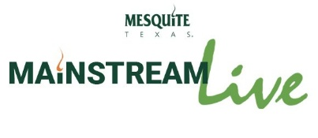
March 27, 2026

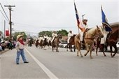

Celebrate Rodeo Day in Mesquite
Mesquite will celebrate its Western roots during Rodeo Day in Downtown Mesquite on Saturday, March 28. Come enjoy the 68th Annual Rodeo Parade at 10 a.m. and check out the food and vendors at the opening day of the Downtown Mesquite Market from 9 a.m.-1 p.m. at Front Street Station. For more information about Rodeo Day, click here.

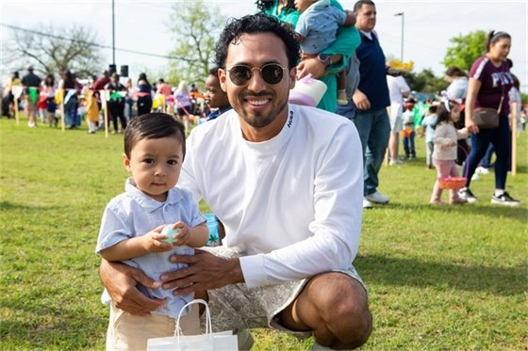

Bunny EGGstravaganza set for April 4
The annual Bunny EGGstravaganza will be held from 9 a.m.-1 p.m. on Saturday, April 4, at Evans Recreation Center, 1116 Hillcrest St. The free community event will feature a variety of festive activities and entertainment, including egg hunts, photo opportunities, bounce houses, and more. Learn more at www.cityofmesquite.com/Bunny.



Statewide Emergency Alert Testing
In addition to regular monthly siren testing, which will occur on April 1, the City of Mesquite will participate in a statewide test of emergency alerting systems from 10 a.m.-12:30 p.m. on April 2. Residents may receive a test alert on their mobile devices or email, depending on the preference selected, and hear outdoor warning sirens during this time. For more information, click here.



Crime is Down in Mesquite: Second Year in a Row with Residents’ Help
For the second time in two years, the City of Mesquite reports a significant decrease in overall crime in the community. Police Chief David Gill presented the new statistics to the City Council this week. There were 929 fewer crimes reported in 2025 than 2024. He said the Police Department’s collaboration with residents has been key to the decline. Read more about the crime rate decline here.

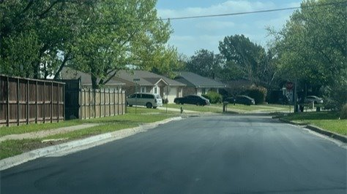

Traffic Update: Eastbound La Prada Drive Lane Closures Underway
The City of Mesquite Streets Division completed an asphalt overlay on the first block of Chapman Drive from Darnell Lane. Concrete curb work is ongoing in other sections as crews continue work along Chapman Drive toward Pioneer Road. For weekly construction updates, visit the La Prada Drive Project Website.



Mesquite Symphony Orchestra Scholarship Gala
The MSO's Scholarship Gala at 7 p.m. on March 28 celebrates young musicians and composers, offering opportunities for both high school and college students to showcase their artistry and further their musical education. Celebrate up-and-coming talent and hear pieces from Beethoven and Texas State Senator Nathan Johnson. Learn more and grab your tickets at www.mesquitesymphony.org.

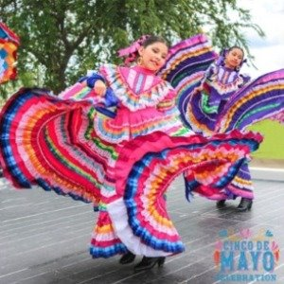

Celebrate Spring with Family Events
Trash Bash, presented by Keep Mesquite Beautiful, is Saturday, April 25. Join the hundreds of volunteers at the Town East Mall parking lot marquee to pick up tools, then get to work cleaning up Mesquite. Cinco de Mayo is May 2 from noon to 5 p.m., in partnership with the Hispanic Forum of Mesquite. This free event takes place at Front Street Station with food, fun, and entertainment. The Citywide Council Picnic takes place Saturday, May 9, 11 a.m., at City Lake Park Pavilion, 200 Parkview Street. All residents are invited to enjoy activities, food and meet your neighbors and councilmembers. To find out about all the spring events, visit www.cityofmesquite.com and check out the community highlights section.



Visit www.cityofmesquite.com/ConnectWithUs to learn about ways to stay connected with us online. Do you have a concern? Send requests for street repair, crime concerns, park issues and more through myMesquite.

  Share on Facebook
  Share on Twitter
  Share via Email

  Copyright City of Mesquite. All Rights Reserved.
  1515 N. Galloway Avenue Mesquite, Texas 75149
  Powered by

